--Load file to table :LKM File to SQL or LKM File to Oracle
--Table to Table : LMK SQL To Oracle
--XML to Table:
LKM used is LKM SQL to SQL . This is Same for XLS. IKM SQL Control Append .
Create Data server, then Physical sever pointing to file location. Put the XSD there . Then inside the model choose XML technology and system table to reverse engineer.
--Multi table
--Use SCD2
--LKM,IKM,CKM,JKM,RKM,SKM
--Use Look Up
--Customize A KM
--Use CKM to correct the errored data
--Resuable mapping
CKM:
Target model must have a KEY defined in ODI level
Flow Control--Works on I$ table before loding to target and check the constrain and inserst to E$ table and deletes data from I$
Static Control --Works on Target table and inserts to E$ and does not delet data from target. Does not create I$ .
Recycle error -- moves data from E$ to I$ and then flow control Is applied .

- how to create customize knowledge modules in odi 12c
- Use case : Add Alter session enable parallel DML in starting of the IKM
- Create a new audit table in IKM to keep a track which records are interested

IKM Integration Process Works in Two Ways
- When staging is on same server as target.
- When staging is on a different server than target (also referred as multi-technology IKMs). CKM operations cannot be performed in this strategy (EX: Table To File )

- 11G vs 12c
- Performance tuning in ODI
- Use of JKM
- Types of Variables
- What is yellow interface and Reusable mapping, Global mapping
Reusable mapping gives the ability to reuse a map in other mapping . It has got input signature and output signature (both are optional) . Input can be provided by other source when used in other mapping ( just like input to Procedure and Function) . Similarly the can be out put signature from that mapping . Best used when we have an analytical expression to be used .
- What is agent and its type ,Oozi agent
- Flow control and Static control, Data quality in ODI
- Load plan vs scenario
- Version control In ODI
- What is procedure
- Pruning date
- Types of KMS
- Usefulness of Context
- Multiple target table loading using spilt
- Load file to table , Table to table , XML to table
- How to do bulk loading in ODI
- Type1 change in OBIA
- Use all the components ODI
- Prepare example of All normalizations
- How to populate a Snapshot table
- Read difference between all KM used in OBIA
- Edit one KM and test it
- Slowly changing dimension
- Exception Handling in ODI
- How to deploy ODI
- Append: Optionally delete all records in the target datastore and insert all the flow into the target.
- Control Append: Optionally delete all records in the target datastore and insert all the flow into the target. This strategy includes an optional flow control.
- Incremental Update: Optionally delete all records in the target datastore. Identify new and existing records by comparing the flow with the target via update key, then insert new records and update existing records in the target. This strategy includes an optional flow control. Does not track history . When IKM Oracle Incremental Update is used , it comes with 4 strategy , NOT_EXISTS,MINUS,POST_FLOW,NONE.
In NOT_EXISTS Strategy : Identical records are eliminated by comparing source to target on every columns using NOT Exit Operator . All of them are marked as I while insertion IN I$. After that Update flag is decided in I$ after comparing I$ with Target based on only update key using IN clause . Then First update happens into the target and then Insert using flag present in I$
In MINUS Strategy : Identical records are eliminated by comparing source to target on every columns using MINUS Operator . All of them are marked as I while insertion IN I$. After that Update flag is decided in I$ after comparing I$ with Target based on only update key using IN clause . Then First update happens into the target and then Insert using flag present in I$
Post Flow Strategy : Total 3 flags are used .All the records from source are loaded into I$ and Flag is I for all of them . Then Update flag is decided if based on the update key on Target . Then Useless flag N is decide comparing all the fields between I$ and Target
None : All the records from source are loaded into I$ and Flag is I for all of them .All of them are updated even if there is no update .
If the source table has less volume of data and the inner subquery is having index on the predicated used in NOT_EXISTS claused , the NOT_EXISTS strategy is good . Not exit does one full table scan of the source and Index scan for target
Minus : It will do two full table scan if there no index defined on the two tables and also does an internal sorting while performing the minus . So if data volume are huge in target. Then not recommended .Best works when both the table has almost similar volume of works.
- Slowly Changing Dimension: Implement a Type 2 Slowly Changing Dimension, identifying fields that require a simple update in the target record when change, fields that require to historize the previous record state.

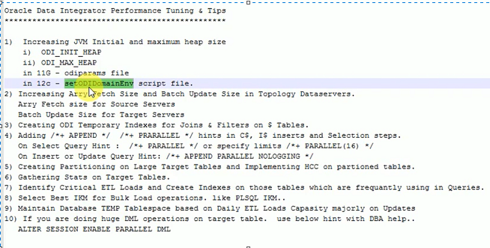

1 NF : Should be atomic , constarin
- each attribute of a table must have atomic (single) values
- Obey domain Constain
2nd Nf:
- Table is in 1NF (First normal form)
- No non-prime attribute is dependent on the proper subset of any candidate key of table.
- All NoN Primary key can should directly depend on all the candidate key
- Every non Prime attribute must depend on complete key not the part of the key
- No Partial Dependency
Batch ID | Couse ID | Year | Course Name | Batch Size
1 | 3 | 2001 | Science | 100
2 | 4 | 2002 | MIL | 200

Here is the Couse Name has partial dependency on Course ID
3RD nf : Table must be in 2NF
- Transitive functional dependency of non-prime attribute on any super key should be remo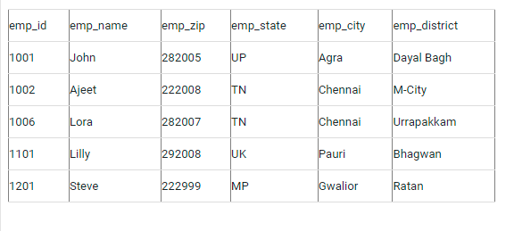ved.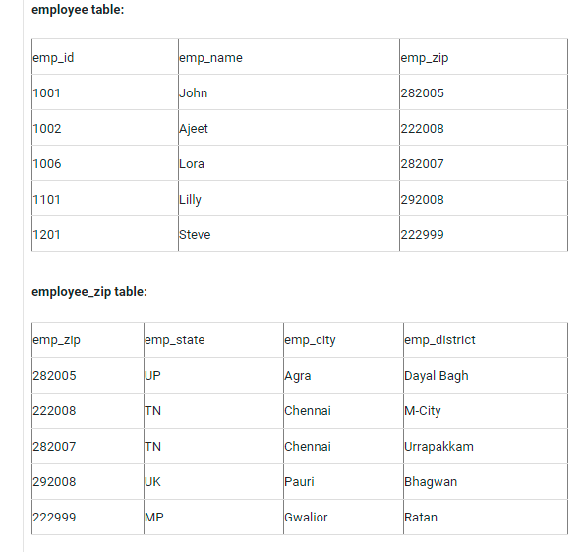


- Error Handling code :

select to_char(substr(ERROR_MESSAGE,1,2000))
from <%=snpRef.getObjectName("L","SNP_STEP_LOG","D")%>
where SESS_NO = <%=snpRef.getSession("SESS_NO")%>
and STEP_STATUS = 'E'

- How to write the sub-queries in ODI?
- I want to always execute the last version of the scenario, I also changed the version in the parameters and set it to -1 instead of 001.
- want commit steps in interval ,Commit Frequency in ODI
- perform Incremental and Initial Load in a single mapping
- What is an Agent and different types of Agents?
Ans:
ODI agent is run time component which orchestrates the data integration process.
They are three types of Agents:
  - Standalone Agent – Light Weight,This can be installed on the server where we want to run ODI . It does not need any application server .
  - J2EE Agent – This comes as a part of fusion middleware installation , needs weblogic application sever .High Availability , Scalability, Security and better manageability
  - Co-located Standalone Agent – Combination both standalone and J2EE agent. It can be installed in source or at target . They can be manage by oracle enterprise manager and must need web logic server .

- LEAD,LAG,LISTAGG,Rank,Dense_rank
- Save point in Oracle
- Collection
set serveroutput on;
declare
--type namelist as varray(10) of varchar(10);
--type namelist is table of emp.ename%type ;
type namelist is table of emp%rowtype ;
V_name namelist :=namelist();
begin
select * bulk collect into V_name from emp where deptno=20;

for i in v_name.first..v_name.last
loop
dbms_output.put_line ( v_name(i).ename);
end loop;
end;
- https://ssssupport.blogspot.com/2020/10/load-duplicate-and-unique-records.html
- What is meant by load balancing and how to do setup for it?
- How to identify whether string is only alpha numeric?
SELECT * FROM DUAL where regexp_like(‘abc123@’,’^[0-9a-zA-Z]+$’)

- What is Flexi fields?
- out file and SQL unload in ODI
- How to implement the logic in procedures if the source side data deleted that will reflect the target side table?
Delete from Target_table where not exists (Select ‘X’ From Source_table Where Source_table.ID=Target_table.ID).

- Partitioning :
- how portioning helps on select and target side
- exchange partitioning
- Everything regarding partitioning
- SQL tuning
- Hints: Parallel hints, append hint, Enable parallel hint ,Index hint
- Autonomous transaction
- Journalizing : Simple set and consistent
- SCD : How the KM works
- Base lining of Oracle plan :
- The SQL plan might change for a query for various reason . Like if index is dropped , or structure is changed , table statistics has changed .
- Optimizer will try to regenerate the plan and that might not be optimal and can be a recessive plan .
- To check if a plan has changed for a query , we can see there will be different plan_hash_value for same sql id for the query in dba_hist_sqlstat and gv$sql.
- Then we need to fix the best sql plan into the SQL base line for optimizer to choose like below
- 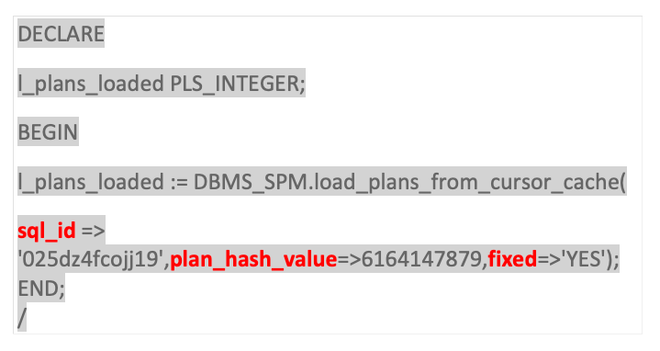
All aspects of managing and monitoring SQL plan baselines can be done through Oracle Enterprise Manager or the PL/SQL packages DBMS_SPM, DBMS_XPLAN and the DBA view DBA_SQL_PLAN_BASELINES.
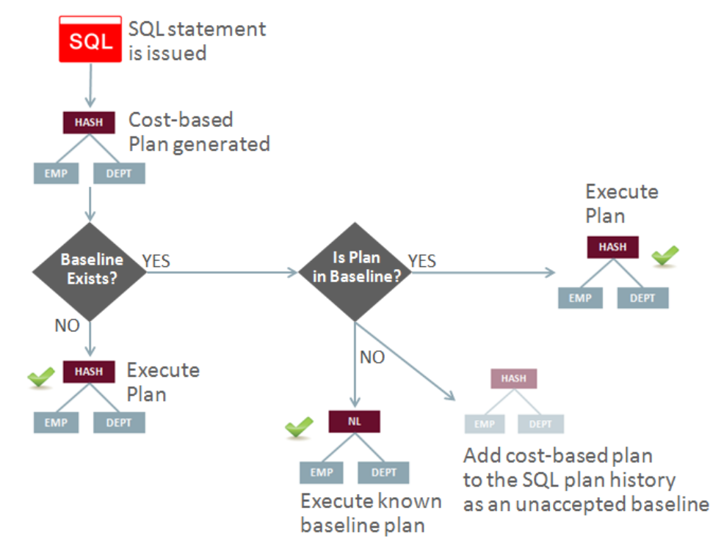
- https://sqlmaria.com/2020/02/25/how-to-use-a-sql-plan-baseline-or-a-sql-patch-to-add-optimizer-hints/
- https://docs.rackspace.com/blog/transfer-sql-plans-by-using-sql-plan-baseline/

- Skip the Row locked (https://stackoverflow.com/questions/13248239/when-should-i-use-for-update-nowait-in-cursors)
- Oracle partition pruning
- Less overhead ? Because older Oracle partitioned tablespaces can be marked as read-only, Oracle has less stress on the redo logs, locks and latches, thereby improving overall performance. For more details, read Robert Freeman's discussion of read-only tablespace performance.
JKM Steps:
  - Source table must have a constrain
  - Add subscriber
  - Add to CDC
  - Start Jornal
  - Use JKM Simple

Select * from j$regions
--when Regions is added to CDC then J$ Captures via trigger the key for which there is a change and with flag like insert or Delete
--Select * from jv$dregions--Data comes from J$ after comparing with Original source table as a part of view definition into JV$D
--JV$ is based on JV$D
--After the interface is created saying only journalized data only in source then then there is a update statement with set the Journal flag to 1 ( Logical Locking) so that it can now appear in JV$ table and JV$ is used in the mapping

Problem with Simple CDC :
- Dependencies between parent and child records
- Handling of more than one subscriber.

Consistent CDC : (https://www.ateam-oracle.com/post/understanding-the-odi-jkms-and-how-they-work-with-oracle-goldengate)
JKM Used : JKM Oracle Consistent

Parent-Child relationship
There are two conflicting requirements when processing parent and child records:
- Parent records must be processed first, or child records cannot be inserted (they would be referencing invalid foreign keys).
- ODI needs to mark the records that are about to be processed (This is the logical lock mentioned earlier), and then process them. But as we are processing the parent records, changes to additional parent and children can be written to the CDC tables. The challenge is that by the time we lock the children records in order to process them, the parent records for the last arrived changes have not been processed yet. Figure 7 below illustrates this: if ODI starts processing the changes in the Orders table at 12:00:00, and then starts processing the changes in the Order Lines table at 12:00:02, the parent record for order lines 4 and 5 is missing in the target environment: order # 3 had not arrived yet when the Orders changes were processed.

- When you define the parameters for consistent set CDC, you have to define the parent-child relationship between the tables. To do so, you have to edit the Model that contains these tables and select the Journalized Tables tab. You can either use the Reorganize button to have ODI compute the dependencies for you based on the foreign keys available in the model, or you can manually set the order. Parent tables should be at the top, children tables (the ones referencing the parents) should be at the bottom.
- Once the tables are ordered, the Consistent Set JKMs can “lock” the records based on this order: children records first, then the parent records. From then on it is safe to process the parent records, followed by the children records knowing that none of these children are missing their references. If more parent and children records are delivered to the J$ tables while the data is being processed (as was the case in Figure 7 with order #3 and the matching order lines), the new records are not locked and are ignored until the next iteration of the integration process
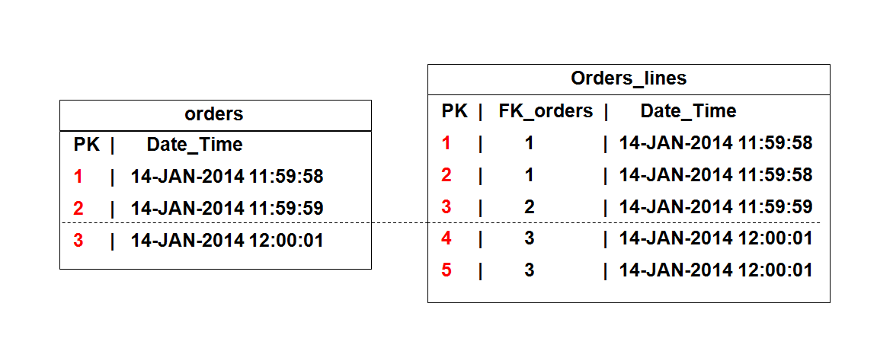
- ODI maintains window_ids that are used to identify when the records have been inserted in the infrastructure.
- When the records of a set (parents and children records) are about to be processed, children records and parent records are logically locked. The KMs do the following operations:
- Make sure that all records have a window_id, then identify the highest available window_ids (this is the Extend Window operation)
- Define the array of window_ids to be processed by the subscribers (this is the Lock Subscriber operation).
These operations are performed in the packages before processing the interfaces where CDC data is processed as shown in Figure 10.
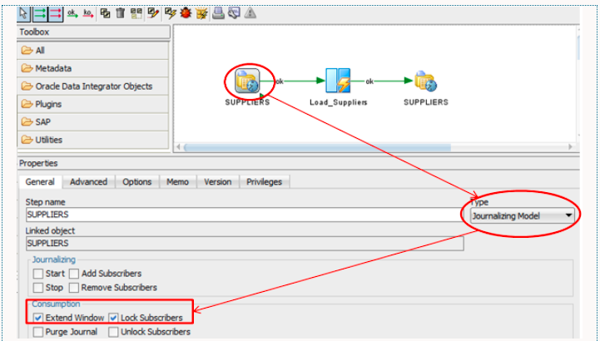

Direct path insert & Read: When does it work, it does it not work ,Undo log , redo log , when we skip
db file Sequential read : – happens when blocks for a table is read from datafile sequentially ( ex: if we have an index ) into buffer cache in SGA. Can have index on the table
db file scattered read – happens when multiple blocks for a table is read from datafile into buffer cache in SGA and scatters all the blocks in the buffer ( Like in case of full index scan or full table scan) . Some time big table size cause the issue to load into Buffer memory .
direct path read – happens when blocks for a table is read from datafile into PGA without going to buffer memory
Situations in which Oracle Database may perform direct path reads include:
- Execution of a CREATE TABLE AS SELECT statement
- Execution of an ALTER REBUILD or ALTER MOVE statement
- Reads from a temporary tablespace
- Parallel queries
- Reads from a LOB segment

Oracle Wait Event: Direct Path Read and Write
If the I/O subsystem doesn’t support asynchronous I/Os, then each wait corresponds to a physical read request. Asynchronous I/O are non-blocking I/O and does not wait for physical I/O to complete .
When the process attempts to access a block in the PGA that has not yet been read from disk, it issues a wait call and updates the statistics for this event.
Resolution :
- If possible the PGA can be sized larger to fit more in-memory sorts reducing the disk sorts.
- Tune the sorts : Determine whether it is possible to reduce the sorting by tuning the SQL statement.
- Parallel DML: Check the I/O distribution across the disks and make sure your I/O is configured for the parallelism being used. Verify that the parameter DISK_ASYNCH_IO is set to true.
- Reduce Full table scans : Use index , try to keep the required DOP
Typical Reasons for a Full Table Scan :
- No index exists.
- The query predicate applies a function to the indexed column
- the indexed column contains nulls
- If the optimizer determines that the query requires most of the blocks in the table, then it uses a full table scan, even though indexes are available. Full table scans can use larger I/O calls. Making fewer large I/O calls is cheaper than making many smaller calls.
- The table statistics are stale: For example, a table was small, but now has grown large. If the table statistics are stale and do not reflect the current size of the table, then the optimizer does not know that an index is now most efficient than a full table scan.
- The table is small.
- The table has a high degree of parallelism.
- The query uses a full table scan hint.

Direct Path Load : ( Block → Segment → Extent → Table Space )
- Loading data at the end of the table directly, Instead in the gaps of data blocks in a data file .
- It does not go via DB buffer
- It is achieved using Append And parallel hint ,sql Unload
- Works when table is in nologging mode , index , trigger , FK are disabled and . It does not write Redo log when log in mode
- Should be used when table are not sensitive and we donot mind they are not recovered .
- Otherwise we should use conventional way of doing things
- Problems :
Space Management : Insert /*+ Append*/ forces high water mark each time we insert some thing . Water mark is the last block of the latest extent . We lose a lot of space as the free space will not be used . Can shrink it later to gain that space again
Locking of session : It locks the table and hence block the other transaction happening concurrently .
Committing Data : You have to commit the data to select after the insert else it will show an error while reading it in the same session
Chance of Data loss : If used in Nologging mode , then data might lost during a crash as there is no redo log . better to back up the table in DB .
Use case to To Use Direct Path :
- Loading stage table with large volume of data .
- Use CTAS or Insert Append with Index enabled
- Partition live table
- Partition exchange
How to make insert faster :
- We can use multi table insert where there is a single target table to insert with different values and we divide the entire 100 inserts to 10 batchs where each batch will have only 1 insert insert in them to insert 10 inserts in one go . This helps saving the round trip between DB and Memory .
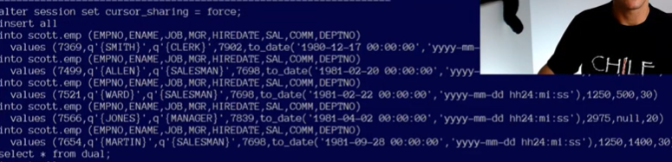

How to Make Updates, and Deletes Faster:
- When deleting , convert the DML to DDL like below
Create table as Keep_Them select * from source where a=b;
Truncate table source;
Insert into source select * from Keep_Them;
- When updating :
Create table as Keep_Them select put_the transformation_here from source where a=b;
Rename source to archive;
Rename keep_them to source ;

What is the difference between lookup and Join?
- Look up has added advantage where we can default a value if there is not matching row in the target table
- or if there multiple matching row , we have row match rules to decide with row to pick up
What is difference between Smart import/Export and import/Export Scenario?
- Smart Import and Smart Export is used to move code along with dependency object. This time of migration is recommended for lower environments like (DEV,QA) where we need to do development.
Row Chaining and Row Migration
- https://www.akadia.com/services/ora_chained_rows.html
- A row is too large to fit into a single database block. For example, if you use a 4KB blocksize for your database, and you need to insert a row of 8KB into it, Oracle will use 3 blocks and store the row in pieces. Some conditions that will cause row chaining are: Tables whose rowsize exceeds the blocksize.
How to avoid Chained and Migrated Rows?
- Increasing PCTFREE can help to avoid migrated rows. If you leave more free space available in the block, then the row has room to grow. You can also reorganize or re-create tables and indexes that have high deletion rates. If tables frequently have rows deleted, then data blocks can have partially free space in them. If rows are inserted and later expanded, then the inserted rows might land in blocks with deleted rows but still not have enough room to expand. Reorganizing the table ensures that the main free space is totally empty blocks.
- The ALTER TABLE ... MOVE statement enables you to relocate data of a nonpartitioned table or of a partition of a partitioned table into a new segment, and optionally into a different tablespace for which you have quota. This statement also lets you modify any of the storage attributes of the table or partition, including those which cannot be modified using ALTER TABLE. You can also use the ALTER TABLE ... MOVE statement with the COMPRESS keyword to store the new segment using table compression.
- ALTER TABLE row_mig_chain_demo MOVE
PCTFREE 20
PCTUSED 40
STORAGE (INITIAL 20K
NEXT 40K
MINEXTENTS 2
MAXEXTENTS 20 PCTINCREASE 0);
- Rebuild the Indexes for the Table
- Row migration is typically caused by UPDATE operation
- Row chaining is typically caused by INSERT operation.
- SQL statements which are creating/querying these chained/migrated rows will degrade the performance due to more I/O work.
- To diagnose chained/migrated rows use ANALYZE command , query V$SYSSTAT view
- To remove chained/migrated rows use higher PCTFREE using ALTER TABLE MOVE.

Difference between functions and Procedures?
Ans.
Functions | Stored procedures
Functions must always return a value. | Stored procedures do not have this requirement.
Functions cannot alter data or objects in a server. | Stored procedures can alter data and objects in database and server.
You can embed functions within a SELECT statement. | Stored procedures cannot be embedded within a SELECT statement.
Both functions and stored procedures can accept parameters. Functions can accept input parameters but can return only a single return value. | Stored procedures can also accept OUTPUT parameters.
TEMP tables can’t be used in functions. | Both TEMP tables and Table variables can be used in stored procedures.

Difference between row_number(), rank() and dense_rank() window functions in SQL
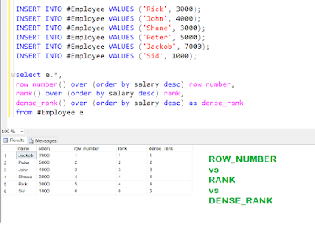

What is Flexifields?
In ODI you can create user-defined fields on certain objects. You can think of these fields as additional attributes for certain objects.
At design time you populate these attributes with values that are then used at runtime, e.g. by a Knowledge Module.
There are various Flexfields defined out of the box for very specific requirements, e.g. there are Flexfields defined on the Datastore object for SAP and HIVE data integration tasks

Question: What is the difference between a oracle global index and a local index?
Answer: When using Oracle partitioning, you can specify the "global" or "local" parameter in the create index syntax:
- Global Index: A global index is a one-to-many relationship, allowing one index partition to map to many table partitions. The docs says that a "global index can be partitioned by the range or hash method, and it can be defined on any type of partitioned, or non-partitioned, table".
- Local Index: A local index is a one-to-one mapping between a index partition and a table partition. In general, local indexes allow for a cleaner "divide and conquer" approach for generating fast SQL execution plans with partition pruning.
Question: three join types:
nested loop ( Small Tables)
merge join ( Large table with Index defined on top of them )
hash join ( Large Table with Equality or inner join )
https://sqlmaria.com/2021/02/02/explain-the-explain-plan-join-methods/
https://logicalread.com/oracle-explain-plans-driving-tables-and-table-joins-h01/#.YZJHZvlBzDc
Question: difference between physical and logical io in oracle
When a block is requested by a query, Oracle looks for it in the Buffer Cache and if found, it results in a Logical read and if it does not find the Block in there it results in a physical read (disk I/O).

Question: how to read trace file in oracle
- ALTER SESSION SET SQL_TRACE = TRUE;
- Formatting Trace Files with TKPROF
- Includes
- call count cpu elapsed disk query current rows
- ---- ------- ------- --------- -------- -------- ------- ------
- Parse 1 0.16 0.29 3 13 0 0
- Execute 1 0.00 0.00 0 0 0 0
- Fetch 1 0.03 0.26 2 2 4 14
Question:how to read awr report for performance issue
https://expertoracle.com/2018/02/06/performance-tuning-basics-15-awr-report-analysis/ 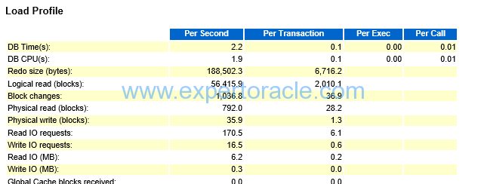

- Type of Index :
B-Tree Index ( Unique (Unique Scan) + Non Unique ( Range Scan)
Bit Map
Reverse Key Index (Reduce leaf block contention but does full scan )
Function based Index

SQL*Loader Concepts
loads data from external files into tables of an Oracle database
Control File, Reject file(input format is invalid.),Discard file( Does not meet the condition) ,Log file

Choosing External Tables Versus SQL*Loader
The record parsing of external tables and SQL*Loader is very similar, so normally there is not a major performance difference for the same record format. However, due to the different architecture of external tables and SQL*Loader, there are situations in which one method is more appropriate than the other.
In the following situations, use external tables for the best load performance:
- You want to transform the data as it is being loaded into the database.
- You want to use transparent parallel processing without having to split the external data first.
However, in the following situations, use SQL*Loader for the best load performance:
- You want to load data remotely.
- Transformations are not required on the data, and the data does not need to be loaded in parallel.

